Patient Intake Form

Name: Date of Birth: Today’s Date:

I Wish to be Contacted in the Following Manner
Email Address: Phone Number Cell/Home/Work:
Mailing Address:
Street City State Zip
I consent to receiving appointment reminders, my healthcare information, confidential documents, through above contact methods.
I understand that this request to receive emails and/or text messages will apply to all future appointment reminders/feedback/health information
unless I request a change in writing.

Emergency Contact Name: Phone: Relation:

Health Insurance Policy (Primary / Secondary / Self-pay) Date Effective Policy Number Group Number

What’s Bothering You? (what are you here for?)

☐ Aching ☐ Burning ☐ Comes and Goes ☐ Constant ☐ Cramping ☐ Dizzy ☐ Dull
☐ Electric Shock ☐ Numbness ☐ Piercing ☐ Pressure ☐ Pulsating ☐ Radiating ☐ Sharp
☐ Shooting ☐ Soreness ☐ Squeezing ☐ Stabbing ☐ Tender ☐ Throbbing ☐ Tingling

When did it start?

How often are the symptoms?

How severe are the symptoms?

How have you managed the symptoms?
Botox Treatments? Y / N

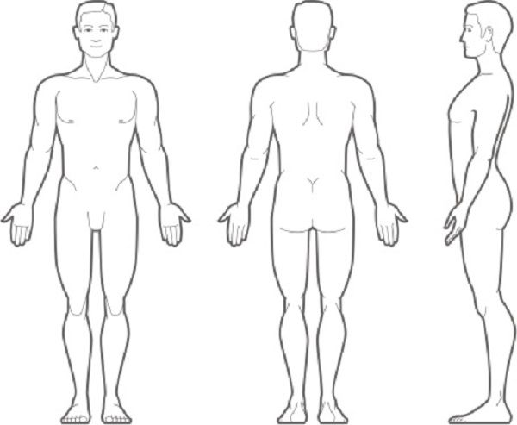
Allergies: (drugs, food, and severity of reaction.)

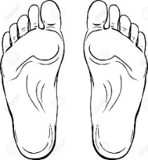

Circle or Cross the areas of discomfort

Past Surgeries and Procedures

Procedure Admission Date Length of Stay

Preventative Care List ongoing Medical Treatments, Special Diets, and Physical Therapies

Social history
Tobacco
__ Current Packs per Day __ Never smoked __ Tried to quit before Date Quit
Alcohol
__ #Drinks per day __ Social Drinker __ Non-Drinker
Caffeinated Drinks
__ #Coffee/Tea Daily __ #Pop/Soda Daily __ Cold Drinks Preferred __ Hot/Warm Drinks Preferred

Do you currently use Marijuana/Cannabis (YES / NO)
If YES, how often and by what method? Does it help alleviate symptoms of your qualifying condition?

Family History (Chronic conditions)
Father Mother Siblings
Grandfather F/M Grandmother F/M

OB and Pregnancy History
__ Age Onset of menses __ Irregular Menses __ Contraceptives __ HRT Use
__ Age of Menopause __ Fertility Drugs __ Abnormal Pap Smears
__ # Pregnancies __ # Full Term __ # Pre Term __ # Miscarriage

Medications (List medications taken past three months)
Name and Dosage How often Taken Reason for Taking Prescribing Physician

Non-Prescription Drugs Taken (Vitamins, Herbs, Etc.)

Review of Systems Blood Type and Rh:

General Sex: __ Male __ Female __ Undifferentiated
__ Fever __ Weight Loss/Gain __ Fatigued __ Hyperactive
__ Chills __ Poor Appetite __ Depressed __ Exposure to Foreign Countries
__ Night Sweats __ Sleep Issues Other:

Skin
__ Rashes __ Open Sores __ Blisters __ Herpes
__ Psoriasis Other:

HEENT
__ Cataracts __ Poor Hearing __ Sinus Infection __ Headaches
__ Glaucoma __ Ringing in Ears __ Dry Mouth __ Double Vision
__ Bloody Nose __ Sore Throat __ Blurred Vision __ Dentures
__ Nasal Allergies Other:

Respiratory
__ COPD/Emphysema __ Pulmonary Fibrosis __ Chronic Bronchitis __ Shortness of Breath
Other:
Cardiovascular
__ Poor Circulation __ Irregular Heartbeat __ High Blood Pressure __ Chest Pains
Other:
Gastrointestinal
__ Stomach Pains __ Diverticulitis __ Hepatitis __ Gastritis
__ Liver Cirrhosis __ Ulcerative Colitis __ Gall Stones __ Polyps
__ Crohn’s Disease __ Diarrhea __ Heartburn Other:

Genitourinary
__ Kidney Stones __ Bladder Infection __ Prostate Problems __ UTI (burning)
__ Urinary Incontinence __ STDs Other:

Musculoskeletal (the common complaints)
__ Osteoarthritis __ Stiff Joints __ Scoliosis __ Hand Problems __ Rheumatoid Arthritis
__ Broken Bones __ Herniated Disc __ Hip Problems __ Lupus __ Neck Problems
__ Shoulder Problems __ Knee Problems __ Spine Arthritis (A.S.) __ Back Problems __ Elbow Problems
__ Ankle Problems __ Swollen Joints __ Wrist Problems __ Foot Problems
Describe:

Endocrine
__ Insulin Dependent Diabetes __ Hypothyroidism __ Cushing Syndrome __ Addison’s Disease
__ Non-Insulin Dependent Diabetes __ Hyperthyroidism __ Goiter Other:

Lifestyle/Exercise

I’m happy with my work relationships Satisfied Dissatisfied Indifferent Explain
I’m happy with my intimate relationships Satisfied Dissatisfied Indifferent Explain
I’m happy with my family relationships Satisfied Dissatisfied Indifferent Explain

Describe Weekly Exercise (be honest)
Describe Daily Food Intake (won’t judge)
Describe Sleeping Habits (promise)
Describe Work Posture/Hazards

I, have filled this to the best of my knowledge.
(Patient Name)

(Patient Signature) (Today’s Date)

